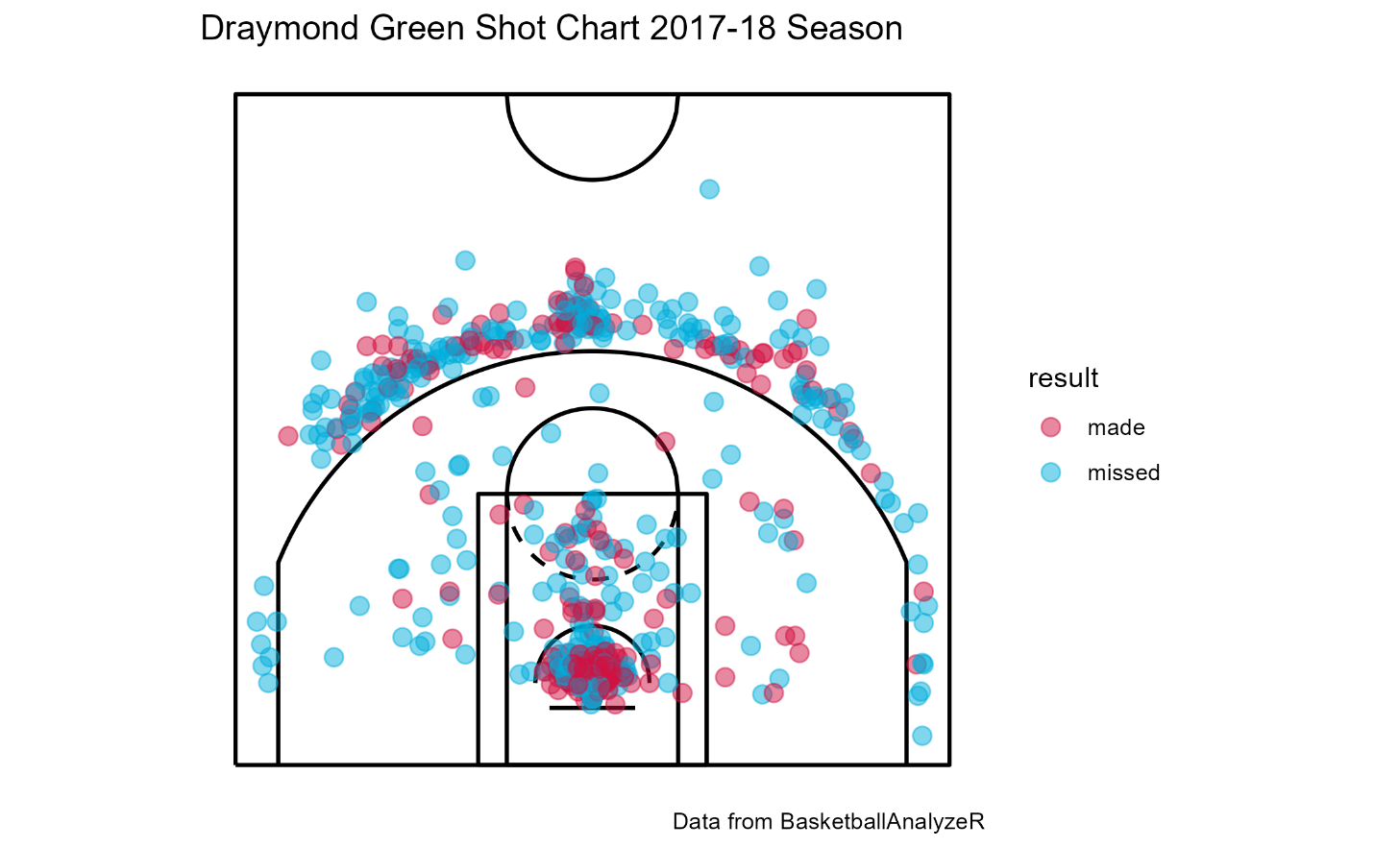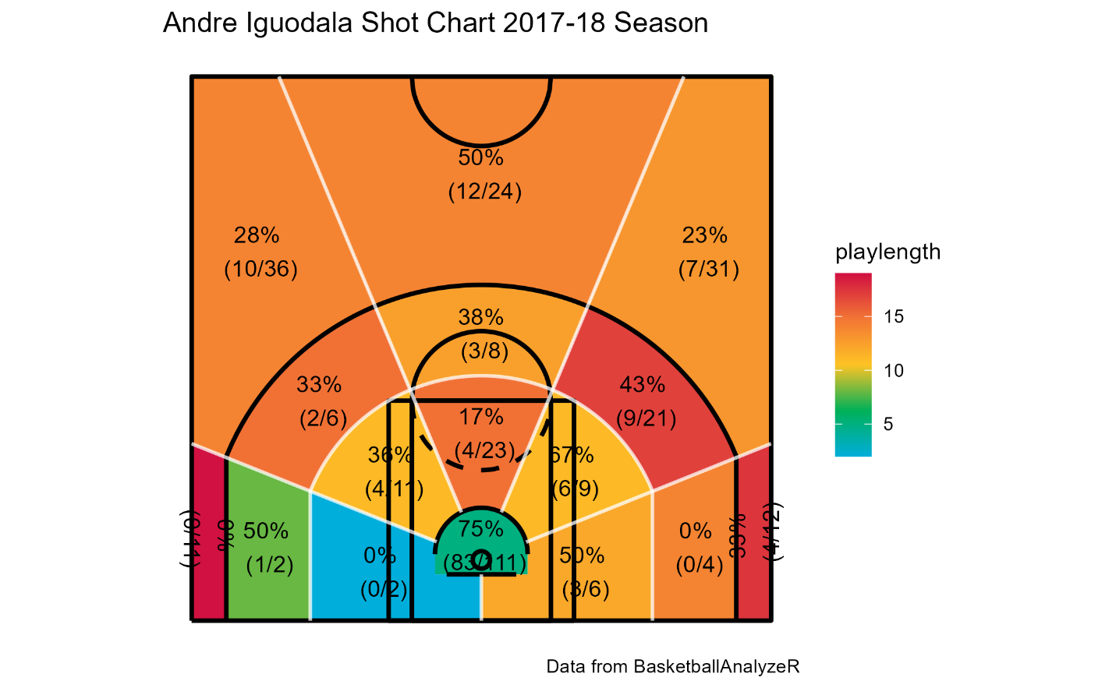
I decided to take a look at the shot charts for two of the forwards for the 2017-18 Golden State Warriors, Draymond Green and Andre Iguodala. When looking at both their shot charts majority of their shots come from inside the paint, which makes sense given their position. I would be worried if that wasn’t the case. When we get to longer range shots is where we see a slight difference between the two players. While both players took most of their longer shots from the top of the arc Iguodala was more effective from the long two-point range and Green was more effective from beyond the arc. When game planning for these two players it would be ideal to keep them on the edge of the arc and make them shoot from range and push them into the corners where they are least efficient.

